**The International Symposium**

**on**

**World Impact of Chinese Modernization**

**Manual**

Host

Academy of Marxism of the Chinese Academy of Social Sciences

Tongren University

Organizer

School of Marxism,University of Chinese Academy of Social Sciences（CASS）

Academy of Marxism of the Tongren University

Department of Foreign Marxism of the Chinese Academy of Social Sciences （CASS）

Co-organizer

Center for International China Studies of the Chinese Academy of Social Sciences（CASS）

Research Center for Contemporary Theoretical Thought of the Chinese Academy of Social Sciences（CASS）

September 15, 2024

Tongren, China

**Contents**

[**Tips 1**](#_Toc3756)

[**Conference Overview 2**](#_Toc1485)

[**Schedule 3**](#_Toc11880)

[**Participants 8**](#_Toc17896)

[**Speaker Profiles 14**](#_Toc21728)

[**About the Academy of Marxism at CASS 26**](#_Toc12024)

[**About the Tongren University 29**](#_Toc1346)

**Minutes of the Conference 31**

# Tips

**Distinguished participants:**

Please take the time to read the conference guide, which will help you understand the conference-related matters:

1. **Time:** 9:00-17:45, Sunday, September 15
2. **Venue:** The 4th Floor, No.1 Multi-function Hall, Rongxin International Hotel
3. **Weather forecast:** Sunday, September 15, Sunny, 21~32°C
4. Please attend the conference on time according to the schedule. Please set the cell phone or electronic equipment to mute.
5. **Contact:**

PI Kunqian +8613985346610

QI Jianguo +86 13701025050

ZHANG Xinchang +86 18285670871

If you have any question, please do not hesitate to contact us in time.

Please accept our apologies for any shortcomings in conference arrangements and service guarantees. Please take your belongings with you when you leave the venue.

Wish you good health and success in your work!

# Conference Overview

**I. The Theme**

The World Impact of Chinese Modernization

**II. The Date**

Sunday, September 15, 2024

**III. The Venue**

The 4th Floor, No.1 Multi-function Hall, Huaguoshan Rongxin International Hotel

# Schedule

|  |  |  |
| --- | --- | --- |
| September 15 | | |
| **Time** | **Activity** | **Site** |
| 9:15—9:55 | **Opening session**  **Moderator:** SHI Wei (President of Tongren University)  **Speakers:**   1. LI Zuoxun (Secretary of Tongren Municipal Committee of the CPC) 2. XIN Xiangyang (Director, Academy of Marxism, Chinese Academy of Social Sciences) 3. SONG Guangqiang (Deputy Secretary of the Education Work Committee of the Guizhou Provincial Committee) 4. ZHU Keqian (Party Secretary of Tongren University) | The 4th Floor, No.1 Multi-function Hall, Huaguoshan Rongxin International Hotel |
| 9:55—10:00 | **Group Photo** |
| 10:00—11:00 | **Keynote Speech**  **Moderator:** TANG Lei （Vice President of Tongren University）  **Speakers (15 minutes each):**  **1. XIN Xiangyang (Director, Academy of Marxism, Chinese Academy of Social Sciences, Researcher)**  Title of Speech: Chinese Modernization Creates the New Human Civilization  **2. Andrew Irving (General Secretary of Communist Party of Australia)**  Title of Speech: Reflections on the Political Development of World Socialism  **3. WANG Chuanli (Professor, School of Marxism, Tsinghua University)**  Title of Speech: Historical Challenges of Chinese Modernization  **4. Thurmer Gyula (President of the Hungarian Workers’ Party)**  Title of Speech: The World Significance of Chinese Modernization |
| 11:00—11:15 | **Tea Break** |
| 11:15—12:30 | **Session I**  **Moderator:** HUANG Xudong (Director of Editorial Department, *Guizhou Social Sciences*)  **Speakers (15 minutes each)：**  **1. Eleni Evagorou (Member of the Central Committee of the Progressive Party of Working People of Cyprus (PPWC), Minister of Organization of the Women’s Movement of the PPWC, Member of the Prometheus Institute)**  Title of Speech: The Far-reaching Impact of Chinese Modernization on the World  **2. SONG Fufan (Professor, Party School of the Central Committee of the Communist Party of China)**  Title of Speech: Historical Changes in the Path and Direction of Development in Contemporary China  **3. Ulrich Peck** **(Consultant, Orient Publishing House of Germany)**  Title of Speech: The Third Plenary Session of the 20th Central Committee of the Communist Party of China Will Make History  **4. Alexander Lomanov (Professor, Deputy Director of the Primakov Institute of World Economy and International Relations)**  Title of Speech: Chinese Modernization and the Development of the Global South   1. **LIU Xinguang (Professor, School of Marxism at Beijing Institute of Technology)**   Title of Speech: Chinese Modernization’s Solution to the Conundrum of Capital and Its Global Impact |
| 12:30—13:30 | **Lunch** | Huaguoshan Rongxin International Hotel |
| 13:30—14:30 | **Break** | Huaguoshan Rongxin International Hotel |
| 14:30—16:30 | **Session II**  **Moderator:** CHEN Airu, Researcher, Academy of Marxism, Chinese Academy of Social Sciences  **Speakers (15 minutes each):**  **1. Andrey Vinogradov (Professor, Director, Center for Contemporary China Studies, Institute of Oriental Studies, Russian Academy of Sciences)**  Title of Speech: The International Significance of Chinese Modernization Experience   1. **Tatiana Smirnova (Member of the Central Auditing Committee of the Communist Party of the Russian Federation, Deputy Director of the State Duma Faction of the Communist Party of the Russian Federation)**   Title of Speech: Socialism with Chinese Characteristics for a New Era: A Successful Model of the State Working for the People’s Interest   1. **LIU Yang (Professor, Vice Dean, School of Marxism, Shanghai University of Finance and Economics)**   Title of Speech: The Peaceful Development Characteristics of Chinese Modernization and Their World Significance   1. **Stavros Mavrodeas (Professor, The Panteion University of Social and Political Sciences in Greece)**   Title of Speech: Economic Policy Adventures in Mainstream Economics   1. **Alexander Pavlov (Director of the Department of Social Sciences at the Institute of Philosophy, Russian Academy of Sciences, Associate Professor)**   Title of Speech: Socialism with Chinese Characteristics is the Foundation of the Success of Chinese Modernization   1. **HUANG Xudong (****Director of Editorial Department, *Guizhou Social Sciences*)**   Title of Speech: Reflections on Some Issues of Chinese Modernization   1. **Pham Van Duc (Member of the Theoretical Council of the Communist Party of Vietnam’s Central, Former Vice President of the Vietnam Academy of Social Sciences)**   Title of Speech: The Achievements and Shortcomings of Socialist Theory and Practice in Vietnam Since Reform   1. **Leon-Marie Nkolo Ndjodo (Institute of Global South and China Studies, University of Maroua)**   Title of Speech: Perspectives on the The Third Plenary Session of the 20th Central Committee of the Communist Party of China | The 4th Floor, No.1 Multi-function Hall, Huaguoshan Rongxin International Hotel |
| 16:30—16:45 | **Break** |
| 16:45—18:30 | **Session III**  **Moderator:** ZHOU Miao, Researcher, Academy of Marxism, Chinese Academy of Social Sciences  **Speakers (15 minutes each):**   1. **Sergei Tokarev (Member of the Central Committee of the Communist Party of the Russian Federation, Second Secretary of the Lipetsk Oblast Committee of the Communist Party, People’s Representative of the Lipetsk Oblast)**   Title of Speech: Contemporary Global Issues and China’s Development as a Model of Socialist Modernization   1. **TAO Wenzhao (Professor, Deputy Dean, Renmin University of China School of Marxism Studies)**   Title of Speech: Super-scale: The Primary Characteristic of Chinese Modernization   1. **Andrei Prokofev (Deputy Director and Researcher at the Institute of Philosophy, Russian Academy of Sciences)**   Title of Speech: Marxism, Justice and Humanity   1. **Blaise Diboro Kanzonuba Tulo (Convener of the Socialist Movement of Ghana in the Accra Region)**   Title of Speech: Common Wealth and Modernization: The Chinese Way to Build Socialism   1. **RAN Guangxian (Professor, School of Marxism at Tongren University)**   Title of Speech: Spiritual Abundance: Exploring Marx’s Perspectives on Spiritual Life   1. **Mbita Chintundya Chitala (Member of the Socialist Party of Zambia, Professor of the Zambian Open University)**   Title of Speech: The Significance and Implications of Chinese Modernization for Development in the Global South   1. **Adham Sayed (Member of the Central Committee of the Lebanese Communist Party, Researcher of the Institute of East Asian Studies, Zhejiang Gongshang University)**   Title of Speech: Chinese Modernization and the Response to the Challenges of Times |
| 18:30—18:45 | **Closing Ceremony**  **Moderator:** TANG Lei, Vice President of Tongren University  **Summary:** PI Kunqian, Professor, Party Secretary, School of Philosophy and History, Tongren University  **Closing Speech:** SHI Wei, President of Tongren University |
| 18:45—19:45 | **Dinner** | Rongxin International Hotel  Western Restaurant and Chinese Restaurant |

# Participants

**I. Foreign participants**

|  |  |  |  |
| --- | --- | --- | --- |
| **Serial Number** | **Name** | **Country** | **Position/title** |
| 1 | Andrew Irving | Australia | General Secretary of the Communist Party of Australia |
| 2 | Adham Sayed | Lebaneses | Member of the Central Committee of the Lebanese Communist Party, Researcher at the Institute of East Asian Studies, Zhejiang Gongshang University |
| 3 | Pham Van Duc | Vietnam | Member of the Central Theoretical Committee of the Communist Party of Viet Nam, former Vice-President of the Hanlin Academy of Social Sciences of Vietnam |
| 4 | Nguyen Thi Phuong Hoa | Vietnam | Deputy Director, Institute of Chinese Studies, Vietnamese Academy of Social Sciences |
| 5 | Tran Thi Thuy Ngoc | Vietnam | Researcher, Director, Department of Oriental Philosophy, Institute of Philosophy, Hanam Academy of Social Sciences, Vietnam |
| 6 | Blaise Diboro Kanzonuba Tulo | Ghanaian | Accra Regional Convener, Socialist Movement of Ghana |
| 7 | Leon-Marie Nkolo Ndjodo | Cameroon | Institute for Global South and China Studies, University of Maroua |
| 8 | Stavros Mavrodeas | Greece | Professor of Panteion Political University of Greece |
| 9 | Gyula Thurmer | Hungary | President of the Hungarian Workers' Party |
| 10 | Eleni Evagorou | Cyprus | Member of the Central Committee of the Progressive Party of Working People of Cyprus (PPWC), Minister of Organization of the Women's Movement of the PPWC, member of the Prometheus Institute |
| 11 | Christos Christou | Cyprus | Member of the Central Committee of the Progressive Party of Working People of Cyprus (PPWC), and Secretary General of the Larnaca Regional Organization of the Progressive Party of Working People of Cyprus (PPWC) |
| 12 | Sergei Tokarev | Russia | Member of the Central Supervisory Committee of the Russian Communist Party, Second Secretary of the Liberec Oblast Committee of the Russian Communist Party, People's Deputy of Liberec Oblast |
| 13 | Andrey Vinogradov | Russia | Director, Center for Contemporary China Studies, Institute of Oriental Studies, Russian Academy of Sciences |
| 14 | Olga Efimova | Russia | Member of the Central Committee of the Russian Communist Party, First Secretary of the Novgorod Regional Committee |
| 15 | Tatiana Smirnova | Russia | Member of the Oversight Committee of the Russian Communist Party.  Deputy head of the factional organ of the State Duma of the Russian Communist Party. |
| 16 | Sami Abu Assi | Syria | Member of the Central Discipline Inspection Committee of the Unified Communist Party of Syria, Researcher at the Beijing Second Institute of Foreign Languages |
| 17 | Mbita Chintundya Chitala | Zambia | Member of the Socialist Party of Zambia and Professor at the Open University of Zambia |
| 18 | Alexander Lomanov | Russia | Deputy Director, Primakov Institute of World Economy and International Relations, Russian Academy of Sciences |
| 19 | Ulrich Peck | German | Consultant, Orient Publishing House, Germany |
| 20 | Yogesh Kumar Bhattarai | Nepal | Former Minister of Culture, Tourism and Civil Aviation of Nepal, Secretary of the Central Committee of the Communist Party of Nepal (Unified Marxist-Leninist), Member of Parliament |
| 21 | Andrei Prokofev | Russia | Deputy Director, Institute of Philosophy, Russian Academy of Sciences |
| 22 | Alexander Pavlov | Russia | Associate Researcher, Head of the Department of Social Philosophy Studies, Institute of Philosophy, Russian Academy of Sciences |

**II. Chines participants(Including media representatives)**

|  |  |  |  |
| --- | --- | --- | --- |
| **Serial Number** | **Name** | **Work Unit** | **Position/Title** |
| 1 | XIN Xiangyang | The Academy of Marxism of the Chinese Academy of Social Sciences (CASS) | Dean/Researcher |
| 2 | QI Jianguo | The Academy of Marxism of the Chinese Academy of Social Sciences (CASS) | Chief of Staff |
| 3 | CHEN Airu | The Academy of Marxism of the Chinese Academy of Social Sciences (CASS) | Researcher |
| 4 | KANG Yanru | The Academy of Marxism of the Chinese Academy of Social Sciences (CASS) | Associate Researcher |
| 5 | ZHOU Miao | The Academy of Marxism of the Chinese Academy of Social Sciences (CASS) | Researcher |
| 6 | SONG Lidan | The Academy of Marxism of the Chinese Academy of Social Sciences (CASS) | Associate Researcher |
| 7 | LEI Xiaohuan | The Academy of Marxism of the Chinese Academy of Social Sciences (CASS) | Associate Researcher |
| 8 | LI Xiaohua | The Academy of Marxism of the Chinese Academy of Social Sciences (CASS) | Staff |
| 9 | LV Xingzhuo | School of Marxism, University of Chinese Academy of Social Sciences(CASS) | PhD |
| 10 | QI Zixiu | ISchool of Marxism, University of Chinese Academy of Social Sciences(CASS) | PhD |
| 11 | HUANG Shumin | School of Marxism, University of Chinese Academy of Social Sciences(CASS) | PhD |
| 12 | ZENG Ziyi | School of Marxism, University of Chinese Academy of Social Sciences(CASS) | PhD |
| 13 | LV Yaolong | School of Marxism, University of Chinese Academy of Social Sciences(CASS) | PhD |
| 14 | YU Yiming | School of Marxism, University of Chinese Academy of Social Sciences(CASS)) | PhD |
| 15 | WANG Chuanli | School of Marxism, Tsinghua University | Professor |
| 16 | SONG Fufan | Party School of the Central Committee of C.P.C | Professor |
| 17 | LIU Xingang | School of Marxism, Beijing Institute of Technology | Dean/Professor |
| 18 | TAO Wenzhao | School of Marxism at Renmin University of China | Vice Dean/Professor |
| 19 | LIU Yang | School of Marxism, Shanghai University of Finance and Economics (SUFE) | Vice Dean/Professor |
| 20 | LI Yang | School of Marxism,East China University of Political Science and Law | Associate Professor |
| 21 | FENG Hao | School of Marxism, Beijing Institute of Technology | Tutor |
| 22 | HUANG Chang | Institute of Historical Theory, Chinese Academy of Social Sciences  International Center for Chinese Studies, Chinese Academy of Social Sciences | Associate Researcher  Under-Secretary-General |
| 23 | HUANG Xudong | Guizhou Academy of Social Sciences | Editorial Director, Guizhou Social Sciences |
| 24 | LI Yingxi | Guizhou Academy of Social Sciences | Associate Researcher VI, Editorial Board, Guizhou Social Sciences |
| 25 | ZHU Siying | China Central Television (CCTV), PRC state TV network | Playwright-Director |
| 26 | LI Dongning | China Central Television (CCTV), PRC state TV network | Moderator |
| 27 | WANG Yungang | China Central Television (CCTV), PRC state TV network | Cinematographer |
| 28 | LI Feng | China Central Television (CCTV), PRC state TV network | Cinematographer |

**III. Participants from Tongren University**

|  |  |  |  |
| --- | --- | --- | --- |
| **Serial Number** | **Name** | **Work Unit** | **Position/Title** |
| 1 | ZHU Keqian | Secretary of the Party Committee of Tongren University | Professor |
| 2 | SHI Wei | President of Tongren University | Professor |
| 3 | TANG Lei | Member of the Party Committee and Vice President of Tongren University | Professor |
| 4 | PI Qiankun | Secretary, School of Philosophy and History, Tongren University | Professor |
| 5 | ZHANG Jianglin | Secretary, School of Marxism, Tongren University | Associate Professor |
| 6 | ZHANG Xinchang | Vice Dean, School of Marxism, Tongren University | Associate Professor |
| 7 | RAN Guangxian | School of Marxism, Tongren University | Professor |
| 8 | CHEN Kaimin | School of Marxism, Tongren University | Professor |
| 9 | LONG Jinju | School of Marxism, Tongren University | Professor |
| 10 | WANG Dezhao | School of Marxism, Tongren University | Professor |
| 11 | XUAN Jie | School of Marxism, Tongren University | Professor |
| 12 | MA Qingqing | School of Marxism, Tongren University | Associate Professor |
| 13 | LONG Youzhen | School of Marxism, Tongren University | Associate Professor |

# Speaker Profiles

**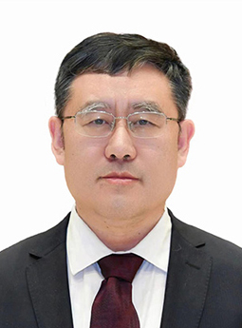**XIN Xiangyang

President and Deputy Secretary of Academy of Marxism of the Chinese Academy of Social Sciences (CASS), Deputy to the 14th National People's Congress, President of School of Marxism of University of Chinese Academy of Social Sciences, Deputy Director of Research Center for the Theoretical System of Socialism with Chinese Characteristics, Executive Director of Research Center for Xi Jinping Thought on Socialism with Chinese Characteristics for a New Era of the CASS, Deputy Director of World Socialism Research Center, Research Fellow-Grade 2, and PhD Supervisor. He graduated in 1991 from Renmin University of China with a degree of Doctor of Laws. He was awarded with State Council Special Government Allowance in 2012, honored as a "Four Batches Talent" in the publicity and cultural system of the Publicity Department of the CPC Central Committee in 2015 and a Leading Talent of the "Ten Thousand Talent Program" of the Organization Department of the CPC Central Committee and the Ministry of Human Resources and Social Securities in 2016. He is also a jury member of both the National Social Science Fund of China and the National Publication Foundation. Other Positions include Vice President of Chinese Historical Materialism Association, and Invited Research Fellow of National Society for the CPC Building Studies. Major Research Results include 20 monographs, more than 30 books which he edited or co-edited, more than 400 articles published in newspapers and academic journals such as *People’s Daily*, *Guangming Daily*, *Studies on Marxism*, and *Studies on Socialism with Chinese Characteristics*, more than 50 national and provincial & ministerial projects which he presided over or participated in, and more than 30 national and provincial & ministerial awards.

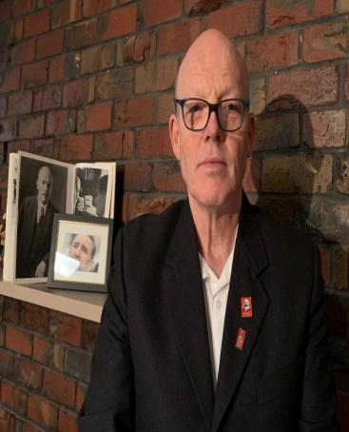**[Australia] Andrew Irving**

Andrew Irving is the General Secretary of the Communist Party of Australia (CPA). He joined the Socialist Party of Australia (now the CPA) in 1979. He has served as Chairman and Vice-Chairman of the CPA International Commission, and has been the CPA General Secretary since 2019.

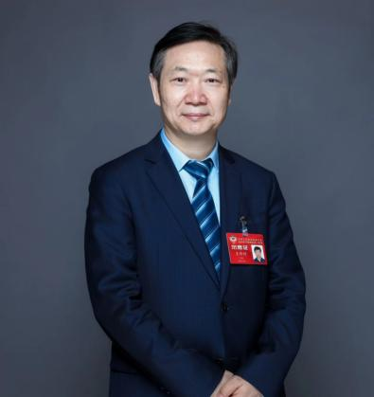**WANG Chuanli**

Professor and PhD Supervisor of the School of Marxism at Tsinghua University, an academic leader in the discipline of Party History and Party Building at Tsinghua. He is a member of the Beijing Municipal Committee of the Chinese People's Political Consultative Conference (CPPCC). He is a Leading Talent in Philosophy and Social Sciences of China's Ten Thousand Talent Program, Vice President of the Committee on Marxist Studies of China Association of Higher Education, and Managing Director of the Chinese Association of Political Science. He is also Contract Research Fellow of both Beijing Municipal Research Center for Xi Jinping Thought on Socialism with Chinese Characteristics for a New Era and World Socialism Research Center of the Chinese Academy of Social Sciences. He is mainly engaged in research on the theory and practice of Marxism and Party building, and has independently published 12 works and more than 200 academic papers in journals such as *CASS Journal of Political Science*, and *Studies on Marxism*. He has presided over and completed three projects supported by the National Social Science Fund of China, and is presiding over a key project of the National Social Science Fund of China and a major commissioned project. He has completed two key research projects of the Social Science Research Base of the Ministry of Education, and a key project funded by the "985" Project of Tsinghua University. His research achievements have been referred to by relevant central leaders, and have been given a Beijing municipal excellent achievement award. He has been awarded the title of "Outstanding Mentor & Good Friend" at Tsinghua University.

**[Hungary] Thurmer Gyula**

Gyula THÜRMER is the Chairman of the Hungarian Workers' Party. Born in Budapest, Hungary, in April 1953, he graduated from the Diplomatic Academy of the Moscow State Institute of International Relations with a PhD in Political Science. From 1976 to 1982, he worked in diplomacy. From 1982 to 1985, he served as the head of the Soviet Affairs Department of the former ruling party, the Hungarian Socialist Workers' Party. From 1985 to 1989, he served as Foreign Policy and National Security Advisor to the General Secretary of the Hungarian Socialist Workers' Party. Since 1989, he has been Chairman of the Hungarian Workers' Party. He's written extensively on politics, international relations, NATO, the EU, and other topics. He's been received by top leaders of countries like China, Belarus, Vietnam, Cuba, Laos, and North Korea. He has visited China many times, including participating in the World Socialism Forum on several occasions.

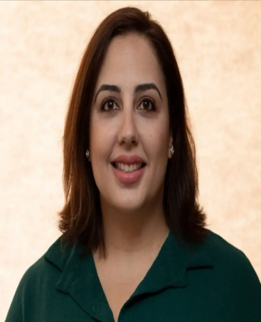**[Cyprus] Eleni Evagorou**

Eleni Evagorou, female, born in 1988, holds a bachelor's degree in Sociology from the University of Cyprus and a master's degree in Social and Public Policy from the University of Leeds in the UK. She is a member of the Central Committee of the Progressive Party of the Working People of Cyprus (AKEL), the Secretary of the AKEL Women's Movement Organization, a researcher at the Prometheus Research Institute and a member of its Scientific Committee, the Secretary of the POGO Women's Movement Organization and its representative in the national women's rights institution, and the head of the organizing committee of the FEMME FEST in Cyprus. Research interests include gender, social identity, and social discrimination.

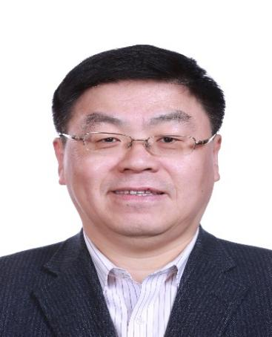**SONG Fufan**

Professor and PhD Supervisor of the Party School of the Central Committee of C.P.C (National Academy of Governance), Director of the Ideological and Political Education Teaching and Research Section of the Party Building Teaching and Research Department of the Party School of the Central Committee of C.P.C (National Academy of Governance). He was Contract Research Fellow of National Society for the CPC Building Studies, an expert of China's Marxist Theory Research and Development Project, and a visiting professor at a number of universities including China University of Political Science and Law. He is mainly engaged in research and teaching on the theoretical system of socialism with Chinese characteristics, theory and practice of the construction of the ruling party, and ideological construction of the ruling party. He has participated in a number of major research projects, such as those of the Leading Group of the CPC Central Committee for Party Building, China's Marxist Theory Research and Development Project and the National Social Science Fund of China, published 3 monographs, and published more than 100 articles in important national and provincial & ministerial newspapers and journals such as Qiushi, People's Daily, Guangming Daily, Economic Daily, and PLA Daily. He has won awards such as the Excellent Works Award of the "Five-One Project" for National Socialist Spiritual Civilization Construction, and National Excellent Books on Party Building.

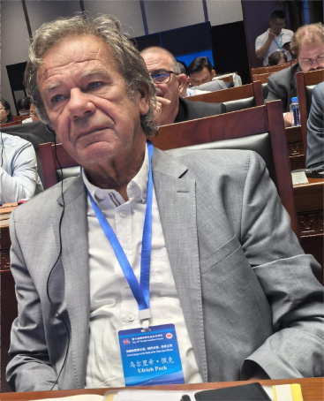**[Germany] Ulrich Peck**

Ulrich Peck, born in 1948. Member of the German Left Party and Former First Secretary of the Rostock District of the Socialist Unity Party of Germany. As a senior researcher at the Berlin East Publishing Company, he is committed to popularizing socialist theories and methods as well as scientific discoveries based on his extensive experience in political activities. In addition to his party duties, he is also engaged in work within the private sector. He previously worked as a Honda car dealer in Japan and was engaged in real estate trade. He previously served as President of the Pigeon Racing Association of the Federal Republic of Germany, where he facilitated the cooperation between German and Chinese racing pigeon associations.

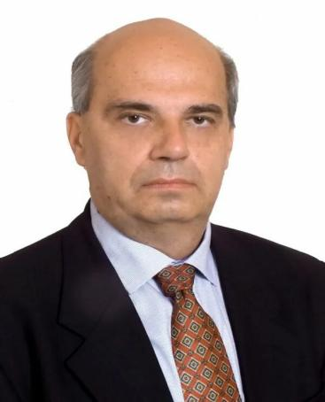**[Russia] Alexander Lomanov**

Alexander Lomanov, a renowned sinologist from Russia and the Deputy Director of the Primakov Research Institute of World Economy and International Relations, Russian Academy of Sciences.He graduated from the Department of Philosophy at Lomonosov Moscow State University in 1989 with a degree in the History of Foreign Philosophy. He received a postgraduate degree in Philosophical Sciences in 1994 and a Ph.D. degree in History in 2001. From 2014 to 2018, he served as a board member of the European Association for Chinese Studies. In 2015, he was awarded the title of "Professor of the Russian Academy of Sciences". He is a member of the editorial boards of Far Eastern Affairs and Journal of St. Petersburg University, and he serves on the scientific advisory board of Russia in Global Affairs.

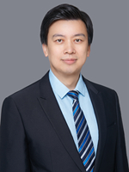**LIU Xingang**

Dean, Professor and PhD Supervisor of the School of Marxism of Beijing Institute of Technology (BIT). Executive Director of BIT's Center for Party Building Studies, Director of BIT's Virtual Simulation Experience Teaching Center, and Deputy Director of BIT's Institute of State Governance. He is a national famous teacher, an expert in national talent programs, and a chief expert for Major Projects of the National Social Science Fund of China. He is mainly engaged in research on the basic principles of Marxism, Xi Jinping Thought on Socialism with Chinese Characteristics for a New Era, Party building and state governance. Prof. LIU has presided over more than 40 various projects, including 2 major projects at the national level and 1 key project at the national level. He has published more than 100 academic papers in journals such as *Social Sciences in China*, *Studies on Marxism*, *Marxism & Reality*, *Guangming Daily*, and *Economic Daily*. He has published 10 monographs or co-authored works. He has won more than 30 honors and awards, including an Influential Figure of Ideological and Political Courses in Colleges and Universities awarded by the Ministry of Education (MOE). He is concurrently a member of the Expert Committee on Marxist Theory of the Chinese Expert Committee on the Evaluation of Humanities and Social Sciences Journals, a member of the Working Committee on Marxism of the Virtual Simulation Experimental Teaching Innovation Alliance, Vice President of the Committee on Marxist Studies of China Association of Higher Education, and a member of the expert committee on the construction of "great ideological and political courses" in Beijing and the integration of ideological and political education in primary and secondary schools and universities.

**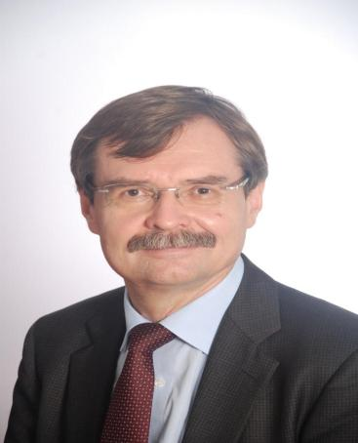[Russia] Andrey Vinogradov**

Andrey Vinogradov, Ph.D. in Political Science, Director of the Contemporary China Research Center at the Institute of Oriental Studies, Russian Academy of Sciences, and Editor-in-chief of Far Eastern Studies. His main research areas include Chinese politics, Chinese modernization, East Asian political systems, and international relations. He has published over 250 academic works, including the monograph Chinese Modernization Model. He has also edited Volume 9 - Reform and Modernization (1976-2009) in the 10-volume series A History of China: From Ancient Times to the Early 21st Century, and Volume 1 - Major Institutions of State Power and Public Administration in the multi-volume series Contemporary Chinese State. He is an expert at the Russian Academy of Sciences and an expert at the Youth Committee of the Russian Academy of Sciences. He serves on the editorial boards of journals such as Russia and the World: Scientific Dialogue, Studies of Russian Laws and Politics, and East Asia: Facts and Analysis. He is also a member of the Defense Politics Committee at Moscow State Institute of International Relations (MGIMO), a member of the International Relations History Dissertation Review Committee at the Peoples' Friendship University of Russia, and a member of the expert committee of the Higher Certification Commission in Political Science. Additionally, he is an expert at the Russian Science Foundation and the Russian Foundation for Basic Research.

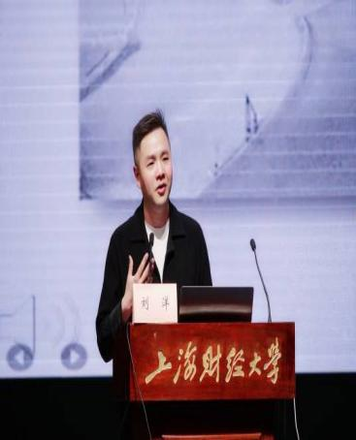**LIU Yang**

Vice dean, professor and doctoral supervisor at the School of Marxism, Shanghai University of Finance and Economics. He is a research fellow at the Shanghai study base for the Xi Jinping Thought on Socialism with Chinese Characteristics for a New Era, research fellow at the Shanghai Institute of Marxist Theory, distinguished research fellow at the Chinese Modernization Institute, Shanghai University of Finance and Economics, member of the China Association for Ethical Studies, council member of the National Society for Economic Philosophy, and council member of the Shanghai Marxism Society. He has presided over a number of projects, including the late-stage funding by the National Social Science Fund of China, youth in social sciences by the Ministry of Education, youth in philosophy and social sciences in Shanghai, special project for education and science in Shanghai, etc. He has published several monographs such as *Mind the World: Global Vision of the Centennial Struggle* and *Historical Transcendence on Marx's View of Freedom in the Perspective of the Modernity Critiques*, and co-authored *A Study of Marx's Humanistic Thought and Its Contemporary Value, Decoding Socialism with Chinese Characteristics for a New Era, etc.* He has also published more than 30 papers in major academic journals, such as *Studies On Marxism, Leading Journal of Ideological & Theoretical Education, Teaching and Research, Studies on Mao Zedong and Deng Xiaoping Theories, Jiefang Daily, etc.* Many of them were reprinted by *China Social Science Digest and Replicated Journals of Renmin University of China.*

Εικόνα που περιέχει Βιβλιοθήκη, ανθρώπινο πρόσωπο, εσωτερικός χώρος, άτομο

Περιγραφή που δημιουργήθηκε αυτόματα**[Greece] Stavros Mavrodeas**

Stavros Mavrodeas is a professor of Social Policy at Panteion University of Social and Political Sciences in Athens, Greece. He holds a Bachelor's degree in Economics from the University of Athens, a Master's degree in Economics from the School of Oriental and African Studies, University of London, and a PhD from Birkbeck, University of London. He previously served as a Professor of Political Economy at the University of Macedonia. He is one of the founders of the Greek Association for Political Economy (GAPE) and has served as Secretary-General and President of the GAPE Committee. Since 2018, he has been a member of the World Association for Political Economy (WAPE) Committee. He is an editorial board member, advisory board member, and reviewer for several academic journals, including Science and Society, China Review of Political Economy, Review of Radical Political Economics, International Critical Thought, World Review of Political Economy, Chinese Journal of Political Economics, Review Of Keynesian Economics, and On Economic Problems. His main teaching and research areas include political economy, macroeconomics, the history of economic thought, labor economics, economic growth and development economics, and the Greek economy. He has authored several books in English and Greek, including "The Limits of Regulation" (Edward Elgar, 2012) and "Greek Capitalism in Crisis: A Marxist Analysis" (Routledge, 2014), and has contributed numerous chapters to collective works. His selected publications include "Development and Crisis: The Turbulent Course of Greek Capitalism" (International Critical Thought, Vol. 3, No. 3, 2013), "Regulation Theory: From Creative Marxism to the Path of Postmodern Disintegration" (Science and Society, Vol. 63, No. 3, 1999), "Capitalist Periodization: Problems and Methods - The Case of Regulation Approach" (Chinese Journal of Political Economics, Vol. 17, 1999), "Work Longer or Harder? The Length and Intensity of Work in Marx's Capital" (Science and Society, Vol. 74, No. 1, 2010), "Unpaid Overtime in Greece: Determinants and Theoretical Explanations" (Industrial Relations Journal, Vol. 45, No. 1, 2014), "Is Cartellier's Monetary Method a Compelling Alternative to Labor Theory of Value?" (Economic Thought, Vol. 6, No. 2, 2017), "Revisiting the Alleged Differences Between Engels and Marx" (International Critical Thought, Vol. 10, No. 3), and "Is the Financialization Hypothesis a Theoretical Blind Spot?" (World Review of Political Economy, Vol. 9, No. 4). In 2018, he was awarded the “21st Century World Political Economy Outstanding Achievement Award” by the WAPE for his book “Greek Capitalism in Crisis: A Marxist Analysis”.

# IMG_256HUANG Xudong

Senior editor and third-class researcher of the Guizhou Academy of Social Sciences, editorial director of *Guizhou Social Sciences*, and doctoral supervisor. He also serves as vice president of the Guizhou Communication Association and vice president of the Guizhou Periodicals Association. Huang has been named a provincial excellent expert and included in the "Top National Talent Program" of the publicity culture system in Guizhou. He is an expert for evaluation of subjects in core journals of Peking University and the Chinese Academy of Social Sciences, expert for evaluation of senior professional titles in social sciences publishing series in Guizhou, and expert for evaluation of outstanding achievements in philosophy and social sciences in Guizhou. He is a think tank expert in Guizhou and a provincial lecturer in the "training institute in the new era" in Guizhou. He has presided over more than 10 national, provincial and ministerial projects. He has published more than 30 academic papers, among which almost 10 have been copied and reprinted in full text by *Replicated Journals of Renmin University of China* and *Xinhua Wenzhai*. His research areas include the basic tenets of Marxism, localization of Marxism in China, public administration, sociology, etc.

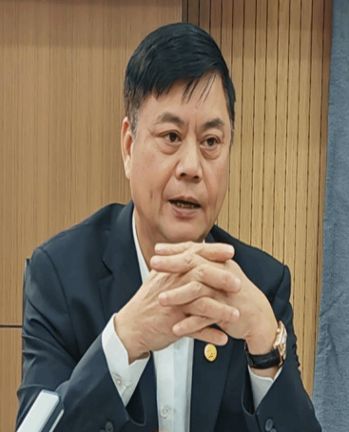**[Vietnam] Pham Van Duc**

Pham Van Duc is the former Vice President of the Vietnam Academy of Social Sciences and a member of the Central Committee for Theoretical Affairs of the Communist Party of Vietnam. Research interesets are historical materialism and dialectical materialism. From 1982 to 2014, he was a researcher, deputy director, director, acting president, and president of the Institute of Philosophy at the Vietnam Academy of Social Sciences, as well as the editor-in-chief of the philosophy magazine. Between 1991-1994, he pursued a PhD in philosophy at the Institute of Philosophy of the Vietnam Academy of Social Sciences. From June 2014 to 2021, he served as the Vice President of the Vietnam Academy of Social Sciences. Since 2021, he has been a member of the Central Committee for Theoretical Affairs of the Communist Party of Vietnam (for the term 2021-2026).

**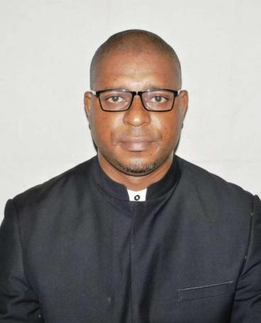 [Cameroon] Leon-Marie Nkolo Ndjodo**

Leon-Marie Nkolo Ndjodo, born in August 1979, Associate Professor at the Dubois Global South and China Studies Center at the University of Maroua. He graduated from the University of Yaoundé I in Cameroon in 2015 with a Ph.D. degree in Philosophy. From 2017 to 2019, he studied at Zhejiang Normal University and obtained a master's degree in Comparative Education. In April 2024, he came to China to attend the 3rd Conference on Dialogue between Chinese and African Civilization, hosted by China-Africa Institute, where he delivered a speech on the theme "The Significance of Chinese-style Modernization for Africa". In April 2024, he also participated in the "African Scholars' Trip to China" organized by China-Africa Institute, during which he visited Fuzhou and Ningde in Fujian Province to exchange and study, and also conduct field research on development achievements such as the construction of Mawei District in Fuzhou, poverty alleviation efforts in Ningde, and the resettlement of the boat-dwelling people in Xiapu. His main research areas include Marxism, the Global South, China-Africa cooperation under the Belt and Road Initiative, and critiques of postmodernism.

**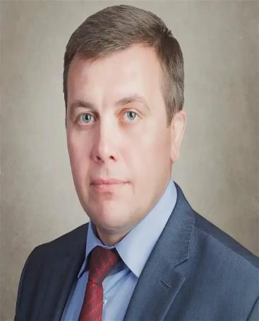[Russian] Sergei Tokarev**

Sergei Tokarev is a member of the Central Control Commission of the Communist Party of the Russian Federation, the Second Secretary of the Lipetsk Regional Committee of the Communist Party of the Russian Federation, and a people's deputy of the Lipetsk Regional Council of People's Deputies.

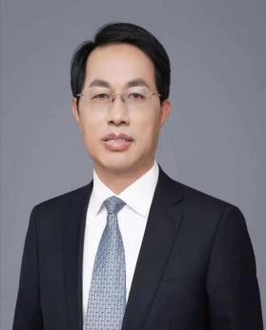**TAO Wenzhao**

Professor and PhD Supervisor of the School of Marxism Studies at Renmin University of China (RUC). Prof. TAO is Deputy Dean of the School of Marxism Studies, Deputy Dean of the Academy of Xi Jinping Thought on Socialism with Chinese Characteristics for a New Era, and Deputy Dean of National Academy of Development and Strategy at RUC. He is Vice Chairman of MOE's "Introduction to Xi Jinping Thought on Socialism with Chinese Characteristics for a New Era" Education Steering Committee. He has been selected as a Leading Talent in Philosophy and Social Sciences of China's "Ten Thousand Talent Program", a cultural icon and "Four Batches Talent" by the Publicity Department of the CPC Central Committee, and enjoys State Council Special Government Allowance. He has presided over more than 10 national projects, including Major Projects of the National Social Science Fund of China and Major Humanities and Social Sciences Projects of the Ministry of Education, and has published more than 400 papers in journals such as *Studies on Marxism*, *Qiushi*, and *People's Daily*.

**[Ghana] Blaise Diboro Kanzonuba Tulo**

Blaise Diboro Kanzonuba Tulo is the convener of the Ghana Socialist Movement in the Accra region and the West African coordinator of the "Pan-Africanism Today" secretariat in South Africa. He graduated from the Kwame Nkrumah University of Science and Technology with a bachelor's degree in Philosophy and Social Sciences, and holds a master's degree in International Relations from the Legon Centre for International Affairs and Diplomacy at the University of Ghana. He has participated in political education programs in Brazil and South Africa, and focuses on issues such as workers' rights, social and welfare reforms, patriarchy and gender-based violence, and climate change.

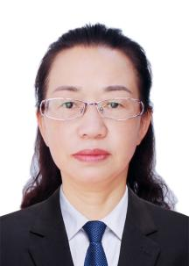 **RAN Guangxian**

Ran Guangxian is a professor and master's supervisor at the School of Marxism at Tongren University. She primarily engages in the teaching and research of fundamental principles of Marxism and sociology, and enjoys a special allowance from the provincial government. She has presided over and completed two NSSFC-funded projects, and a number of provincial and municipal level projects. She has published over 50 academic papers in journals such as "Philosophical Trends", "Gansu Social Sciences" and "Guizhou Social Sciences", including 19 in C-level journals, 4 reprinted in full on the China Social Science Excellence and 1 reprinted in China University Academic Abstracts. She has received 1 first prize and 1 second prize for the Award for Outstanding Achievements in Philosophy and Social Sciences of Guizhou Province, 1 second prize for the Award for Outstanding Achievements in Humanities and Social Sciences Research of Guizhou Universities and Colleges, 1 third prize for the Award for Outstanding Achievements in Educational Science Research of Guizhou Province, and 3 first prizes for the Award for Outstanding Achievements in Philosophy and Social Sciences of Tongren City.

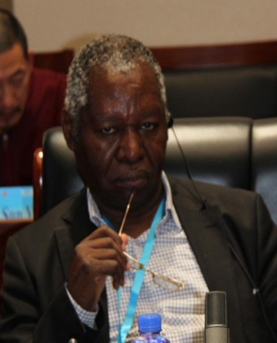**[Zambia] Mbita Chintundya Chitala**

Mbita Chintundya Chitala, male, born in 1955. Former Deputy Minister of Ministry of Commerce, Trade and Industry of Zambia, Professor at Zambian Open University, Member of the Socialist Party of Zambia, and Zambian Political Economist.From 1991 to 1994, he served as Deputy Minister of Ministry of Finance and Economic Affairs of Zambia; from 1994 to 1995, he served as Deputy Minister in the Office of the President of Zambia; from 2002 to 2003, he served as Deputy Minister of Ministry of Local Government and Housing of Zambia; from 2003 to 2005, he served as Deputy Minister of Ministry of Finance and National Planning of Zambia; from 2005 to 2006, he served as Deputy Minister of Ministry of Commerce, Trade and Industry of the Republic of Zambia; from 2007 to 2008, he served as Ambassador Extraordinary and Plenipotentiary of Zambia to Libya, and was also accredited to Algeria, Tunisia, Morocco, Chad, Mauritania and Western Sahara.

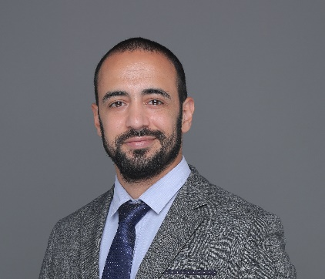**[Lebanon] Adham Sayed**

Adham Sayed, a Lebanese, born in 1988, is a member of the Central Committee of the Lebanese Communist Party. He holds a doctoral degree in economics from the Huazhong University of Science and Technology. He currently serves as a senior research fellow at the Institute of East Asian Studies at the Zhejiang Gongshang University. Research interests include political economy, economic development, and international relations. He has published articles in various academic journals and political magazines, including Economic Research Journal, Chinese and Arab Studies, Arab World Studies, Contemporary World, China Social Sciences Today, China Daily, CGTN Opinion, China Youth Daily, and Beijing Review; and authored the book *This is how it was in Wuhan — Diaries of Quarantine Days*.

**[Russia] Tatiana Smirnova**

Member of the Supervisory Committee of the Russian Communist Party, deputy Director of the faction organ of the State Duma of the Russian Communist Party.

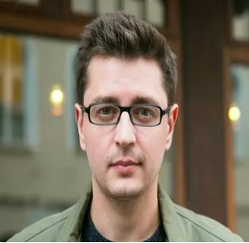**[Russia] Alexander Pavlov**

Director, Researcher, and Doctor of Philosophy, Department of Social Philosophy Research, Institute of Philosophy, Russian Academy of Sciences.

Professional direction: Political Philosophy

Main works and articles: “Postmodernism: How Social and Cultural Theory Explains Our Time”, “The Future of 2049: The Political Potential of Late Postmodernism”, “Utopia in Modern Western Marxism: Anomaly, Hope, Science” and so on.

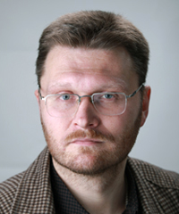**[Russia] Andrei Prokofev**

Deputy Director, Researcher, Doctor of Philosophy, Institute of Philosophy, Russian Academy of Sciences.

Professional direction: Philosophy, ethics

Main works and articles: “Justice and Responsibility: Social and Ethical Issues in Moral Philosophy”, “Applied Ethics in the Twenty-first Century: The Challenge of Changing the Paradigm of University Education”, “Moral Responsibility, Moral Sanctions and Moral Values and normative Connotations” and so on.

# About the Academy of Marxism of CASS

The Academy of Marxism of the Chinese Academy of Social Sciences (CASS), approved by the Meeting of the Standing Committee of the Political Bureau of the CPC Central Committee on May 19, 2005, is a state-level Marxist research institute which was reorganized on December 26, 2005 on the basis of the former Institute of Marxism-Leninism-Mao Zedong Thought.

  Responsibilities and tasks of the Academy of Marxism include: adhering to the guidance of Xi Jinping Thought on Socialism with Chinese Characteristics for a New Era, continuing to thoroughly implement the spirit of General Secretary Xi Jinping’s important speech at the Symposium on the Work of Philosophy and Social Sciences and his three congratulatory letters to the CASS, strengthening commitment to the “four consciousnesses,” “the four-sphere confidence,” and “the two upholds”; taking the study, research, interpretation and publicization of Xi Jinping Thought on Socialism with Chinese Characteristics for a New Era as the first and foremost task, taking China’s socialist reform & opening-up and modernization practices as the foundation, taking the major theoretical and practical issues of concern to the CPC, the state and the people as the guidance, carrying out comprehensive and in-depth study of the classic works and fundamental principles of Marxism, the history of Marxist development, sinicization of Marxism (Mao Zedong Thought, Deng Xiaoping Theory, Theory of Three Represents, Scientific Outlook on Development, and Xi Jinping Thought on Socialism with Chinese Characteristics for a New Era), and historical evolution and basic experience of the international communist movement, socialist movements and trends in contemporary world, and Marxism abroad; making organic combination of academic research, theoretical publicization and practical application of Marxism, carrying out extensive exchanges and cooperation with domestic and foreign counterparts, actively offering advice and making suggestions, serving the socialist cause of China and the world, striving to be at the head of the tide of the times, understanding the changes of the past and present, giving a voice to new ideas, so as to better fulfill the responsibilities of “three major orientations” of the CASS and to build “three major systems,” realizing the prosperity of Chinese academics, the development of Chinese theories, the dissemination of Chinese ideas, the development of contemporary Chinese Marxism and 21st century Marxism, and making greater contributions to accelerating the construction of philosophy and social sciences with Chinese characteristics and the realization of the Chinese dream of the great rejuvenation of the Chinese nation.

The Academy consists of five research departments: Department of Xi Jinping Thought on Socialism with Chinese Characteristics for a New Era, Department of Fundamental  Principles of Marxism, Department of Sinicization of Marxism, Department of International Communist Movement, and Department of Foreign Marxism; 18 research units: Research Unit of Fundamental Theories, Research Unit of Basic Strategies, Research Unit of Party Building and History, Research Unit of Ideology and Social Trend, Research Unit of Marxist Philosophy, Research Unit of Marxist Political Economy, Research Unit of Scientific Socialism, Research Unit of Development History of Marxism, Research Unit of Mao Zedong Thought, Research Unit of Theoretical System of Socialism with Chinese Characteristics, Research Unit of Ideological and Political Education,

Research Unit of Marxist Atheism, Research Unit of History of the Internatioal Communist Movement, Research Unit of Contemporary World Socialism, Research Unit of Contemporary Capitalism, Research Unit of Left-Wing Thought, Research Unit of Theory of the Communist Parties Abroad, and Research Unit of Western Marxism; 1 operation unit: office of information network and data; 5 administrative departments: executive office, office of academic research, human resources office, general coordination division of “three offices,” and secretariat of Research Center for Xi Jinping Thought on Socialism with Chinese Characteristics for a New Era. There are publications and websites such as Studies on Marxism, World Socialism Studies, Trends of World Socialism Studies,Science and Atheism, International Critical Thought (in English), World Review of Political Economy (in English), Marxist Digest, Marxist Theory Research and Discipline Construction Yearbook, and Marxist Research Network (http://myy.cass.cn/).

The Academy of Marxism is one of the main supporting units of the Academic Division of Marxist Studies, and is the supporting unit of the first batch of professional think tanks of the CASS, including “Think Tank for Marxist Theory Innovation” and “Think Tank for Ideological Studies.” It is in charge of managing four national academic associations, including the Chinese Historical Materialism Society, China Association of Political Economy, Chinese Society for the Study of Foreign Economic Theories and Chinese Association of Atheism as well as four non-entity research centers, including Research Center for Contemporary Theoretical Thought of the CASS, Research Center of Economic and Social Development of CASS, Center for Atheistic Studies of the CASS, and Research Center for National Cultural Security and Ideological Construction of the CASS.

Research Center for Xi Jinping Thought on Socialism with Chinese Characteristics for a New Era of the CASS, Research Center for the Theoretical System of Socialism with Chinese Characteristics, and World Socialism Research Center, as well as the Office of the Marxist Project of the CASS, and the Office of the Thought and Theory Writing Group of the CASS are also located at the Academy of Marxism.

Current leaders include: Luo Wendong,Party Secretary of the Academy of Marxism; Xin Xiangyang,President and Deputy Secretary of the Academy of Marxism, and President of School of Marxism of University of Chinese Academy of Social Sciences; Chen Zhigang, Secretary of the Discipline Inspection Commission and Vice-President of the Academy of Marxism; Yu Haiqing, Vice-President of the Academy of Marxism.

The Academy of Marxism has now 127 professional staff, among which there are 106 researchers, 21 auxiliary staff (including editorial staff). Among the professional staff, there are 34 people possessing senior high-level professional title, 39 associate title, 53 middle level, and 1 elementary level; 107 people possessing a PhD degree, 17 Master degree and 3 undergraduates. There are 17 people in the Academy of Marxism awarded Special Government Allowances of the State Council, several scholars obtaining the honors including Young and Mid-Aged Experts with Outstanding Contributions to the Nation, National “Millions Talents” Project, “Four Batch Talents,” Leading Talents in the National “Ten Thousand People Program” and so on, and several listed the Chief Expert and Leading Expert of the Marxist Project of the Central Committee among which 3 are members of the Academic Divisions of the CASS.

Scholars from the Academy of Marxism have been granted the major projects and specially commissioned projects of the National Social Science Foundation (the Marxist Project of the Central Committee) for many times, and many scholars have been granted the annual projects of the National Social Science Foundation every year. In addition, they have also been granted a number of major projects of the Innovation Project of the CASS as well as major projects, key projects, base projects, and sub-projects of mega-projects of the CASS for research on national conditions. At the same time, the Academy of Marxism undertakes a number of projects assigned by the central government and the CASS every year.

The Academy of Marxism is the lead cooperation unit of School of Marxism of University of Chinese Academy of Social Sciences with Xin Xiangyang serving as the President of the school and Lin Jianhua the Vice-President. School of Marxism of University of Chinese Academy of Social Sciences is one of the first 12 schools for integrating research and education in a bachelor-master-doctoral program, undertaking the important task of cultivating talents specialized in Marxist theory. The school enrolls undergraduate students in two majors: Marxist Theory and Ideological and Political Education; and enrolls graduate students in the following disciplines: Fundamental Principles of Marxism, Development History of Marxism, Studies on the Sinicization of Marxism, Scientific Socialism and the International Communist Movement, Studies on Marxism Abroad, Ideological and Political Education, Party Building, and so on. Thirty-two scholars from the Academy of Marxism are serving as postgraduate supervisors in the school, including 10 PhD supervisors and 22 Master supervisors. Currently there are 165 undergraduates, 23 students in the master program and 36 doctoral candidates enrolled in the school.

The Academy of Marxism has a Postdoctoral Mobile Station of Marxist Theory, which recruits postdoctoral scholars in the disciplines of Fundamental Principles of Marxism, Development History of Marxism, Studies on the Sinicization of Marxism, Scientific Socialism and International Communist Movement, Studies on Foreign Marxism, Ideological and Political Education, Party Building and so on. Senior visiting scholars are also recruited. There are currently 12 postdoctoral scholars and 24 visiting scholars.

**[About the University](https://www.gztrc.edu.cn/ywb/About_the_University1/About_Us.htm) Tongren University**

Tongren University is located in Tongren City, Guizhou Province, known for its reputation as the "Pure Land of Brahma and Peach Blossom Land." The university is situated at Chuandong Education Park, at the foot of Mount Fanjing and along the banks of the Jinjiang River. The university traces its origins to Mingde School, established in 1920, and was upgraded to an ordinary undergraduate institution in 2006. In 2020, it was approved as a master's degree-granting institution. Tongren University is a national "13th Five-Year Plan" project construction university integrating production and education, a recipient of the Huang Yanpei Vocational Education Award "Excellent School Award," a participating institution in the Ministry of Education's Scientific Working Capacity Enhancement Program, a pilot university for application-oriented transformation in Guizhou Province, and a national and provincial civilized unit and a national base for ethnic unity and progress education. It is also a demonstration model of the "Three-All Education" in Guizhou Province.

The university covers approximately 796 acres, with about 59,000 square meters of laboratory and internship space. The total value of teaching and research equipment amounts to 113.916 million yuan. There are 35 undergraduate programs offered, covering disciplines such as education, engineering, science, literature, management, arts, and agriculture. The university has 956 staff members (199 with doctoral degrees, 324 with master's degrees), 179 professors, 2 doctoral supervisors, 131 internal master's supervisors, and 112 external part-time master's supervisors. Among the faculty are 1 recipient of the State Council Special Government Allowance, 5 provincial experts, 2 recipients of the Provincial Government Special Allowance, 2 talents at the "Hundred" level in Guizhou Province, 51 talents at the "Thousand" level in Guizhou Province, 4 academic leaders in philosophy and social sciences in Guizhou Province, and 7 provincial "Golden Teachers."

The university adheres to the goal of cultivating high-quality application-oriented talents, developing a unique "Mountain-shaped" talent cultivation model, and gradually enhancing its talent training capacity. It currently has 4 nationally certified teacher training programs, 1 National Excellent Agricultural and Forestry Talent Education and Training Program, 1 National Ethnic Culture Inheritance and Innovation Demonstration Program, 1 Ministry of Education-approved Sino-foreign cooperative undergraduate education program, 4 Guizhou Province Excellent Talent Education and Training Programs, 6 provincial comprehensive reform pilot programs, 2 provincial characteristic programs, 10 provincial first-class undergraduate programs, 1 national first-class course, and 38 provincial first-class courses. Over the past three years, the university has obtained 51 provincial and ministerial-level teaching reform projects and industry-education integration projects, 75 national student innovation and entrepreneurship training programs, and 200 provincial-level programs.

The university actively adapts to regional economic and social development needs, continually strengthening discipline construction and scientific research. It currently has one "Regional First-Class Discipline Cluster I" in "Educational Development and Rural Revitalization in Mountain Areas," one regional first-class construction discipline in Guizhou Province, one provincial characteristic key discipline, and five provincial key disciplines. In the past three years, the university

has received a total of 113.59 million yuan in research funding, undertaken 1,213 various projects, including 30 national projects and 93 provincial and ministerial-level projects. The faculty have published 518 papers in core journals, authored 132 monographs, edited 8 textbooks, and obtained 420 authorized patents.

The school adheres to an internationalization strategy, actively engaging in international exchange and cooperation. Tongren University pursues an internationalized education strategy and actively engages in international exchanges and cooperation. To date, the university has trained 1,568 high-level engineering and management talents for countries along the "Belt and Road" Initiative; established "Talent Training Bases" with the Ministry of Education of Cambodia, the Education Departments of Luang Namtha Province, Savannakhet Province, Xayaburi Province, and Vientiane Province in Laos; formed friendly cooperative relationships with 85 universities and educational institutions in the United States, the United Kingdom, South Korea, Thailand, Cambodia, Laos, Malaysia, Indonesia, Italy, and other countries (regions); and sent faculty and students for international exchanges and visits. The university focuses on promoting educational international cooperation under the "Belt and Road" initiative, establishing 10 overseas internship and training bases in Thailand, Laos, and Cambodia around ten key disciplines. It has established the "Lao Studies Center," a comprehensive institution integrating academic research, talent training, and policy consultation.

Continuing the original mission over a century and bearing the responsibility of educating people. Looking forward, Tongren University will always hold high the great banner of socialism with Chinese characteristics, guided by Xi Jinping Thought on Socialism with Chinese Characteristics for a New Era. It will adhere to high-quality development, fully implement the fundamental task of cultivating virtues and talents, firmly promote connotative development, characteristic development, and integrated development, continually enhancing its core competitiveness, and strive to build Tongren University into a distinctive high-level teaching, research, and service-oriented university, contributing to the new chapter of colorful Guizhou's modernization construction.

# Minutes of the conference